Ministry of Economy
Republic of Kosova
Call for expression of interest for the candidate for operating European Digital Innovation Hub- EDIH in Kosova

Deadline: 06 of December 2023

This document presents a call for proposals for the creation of a European Digital Innovation Hub (EDIH) in the Republic of Kosova. The call will take place first at a national level, followed by a call at the European level. Only a digital innovation hub (DIH) that has been selected through the national process will be admissible to the European call. The selection process at the national level is detailed in this document. This form should be filled in English.
Context
The digital transformation of the economy is a key level for Europe, and countries that aspire to be part of the European Union, in order to remain competitive internationally. Our companies and public sector organisations need to integrate digital technologies into their business processes, products, and services to fully benefit from the efficiency gains and innovation they may bring, while remaining environmentally sustainable and reducing greenhouse gas emissions. In particular, the smart use of data can be a powerful lever to drive growth, create new jobs and open up new business models and innovation opportunities. Even though Kosovo’s ICT sector has made significant progress in the recent years, the level of digitalisation however remains uneven, depending on the sector, and size of a company.
In Kosova, a European Digital Innovation Hub (EDIH) would have a key role to play to address these gaps. The idea of local DIH’s are to be embedded in the local economy with the objective to strengthen the economy by supporting the adoption of innovative digital technologies by the industry. In the Digital Europe Programme (DEP), significant funds will be invested in capacity building in high performance computing (HPC), and artificial intelligence (AI). DEP will also focus on advanced digital skills, creating an offer of trainings and job placements, as well as on delivering digital service infrastructures (DSIs) for areas of public interest. One of the important missions of the EDIH in Kosova is thus to make sure that these capacities are actually used by companies, that they can experiment with these technologies and apply them according to their needs.
The goal of this call is to identify two or more potential EDIHs to provide unified services to local businesses across Kosova, as well as to enhance (or create) cross-border cooperation and collaboration.
Definition of a Kosova’s EDIH
A European Digital Innovation Hub (EDIH) is a single organisation or a coordinated group of organisations with complementary expertise, with a not-for-profit objective that support companies - especially SMEs and mid-caps - in their digital transformation. EDIHs offer services such as (see Figure 1):

- Test before invest:
  - awareness raising,
  - digital maturity assessment,
  - demonstration activities,
  - visioning for digital transformation,
  - fostering the integration,
  - adaptation and customisation of various technologies,
  - testing and experimentation with digital technologies (software and hardware),
  - knowledge and technology transfer.
Special focus will be on the key technologies promoted in Digital Europe Programme: HPC, and AI.

- Skills and training:
  - advertising,
  - hosting or providing of training, boot-camps, traineeships,
  - supporting the implementation of the short-term advanced digital skills training courses job placements developed as part of the DEP Advanced Digital Skills pillar.

- Support to find investments:
  - access to financial institutions and investors,
  - supporting the use of relevant financing mechanisms.

- Innovation ecosystem and networking:
  - help companies get into contact with other companies of their value chain, with innovators, or early clients that want to test solutions. EDIHs should play this brokering role and bring e.g. end-users and potential suppliers of technological solutions into contact with each other for e.g. experimentation and testing, to promote co-creation. The non-profit objective of EDIHs is important in this respect, and they might promote local companies to improve the overall economic strength of their local economy. When suitable local partners are not found, the hubs can network with other EDIHs to find a matching partner elsewhere in the region and Europe. Hubs can only become good brokers if they do regular technology scouting, in order to map the innovation ecosystem, and understand needs and opportunities. Structured relationships with regional authorities, industrial clusters, SME associations, business development agencies, incubators, accelerators, EEN, and chambers of commerce will greatly help the brokering function.

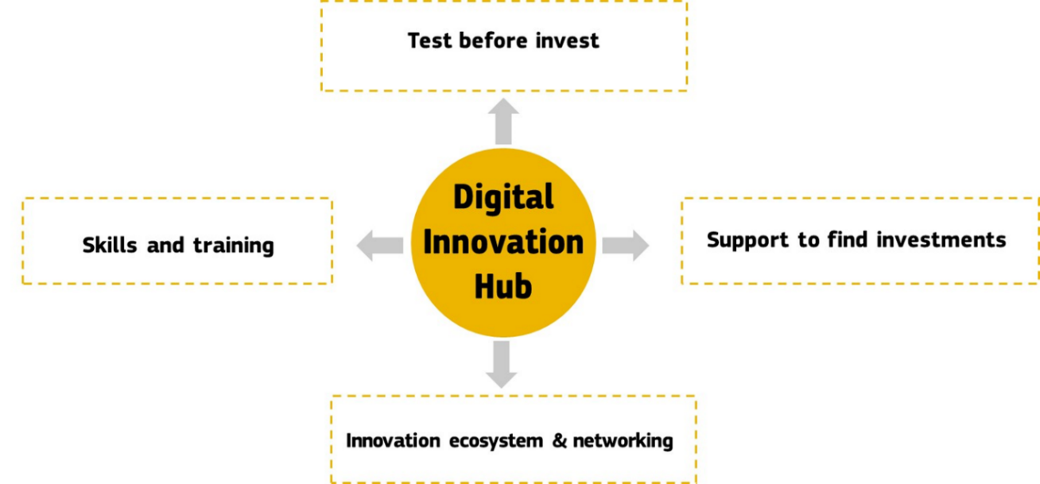
Figure 1: Potential services to be offered by EDIH

The services of the EDIHs should be complementary to and not replace existing (commercial) services of e.g. training suppliers or ICT companies. Through the function “Innovation ecosystem & Networking”, a hub works also as a broker and matchmaker between needs of certain companies and possible suppliers. Suppliers can be involved in the “Test before invest” or “Skills and training” activities.
Calendar and selection process
National selection
Ministry of Economy based on the government decision No. 22/96, date 14.09.2022, is in charge of negotiating with the European Commission and coordinating all activities at the national level regarding Digital Europe Programme.
This call will open on the 6th of November 2023 and closed on 6th of December 2023. The applications will be evaluated by an evaluation committee of the Ministry of Economy during first part of December 2023. The application form for the project outline phase is given hereafter.
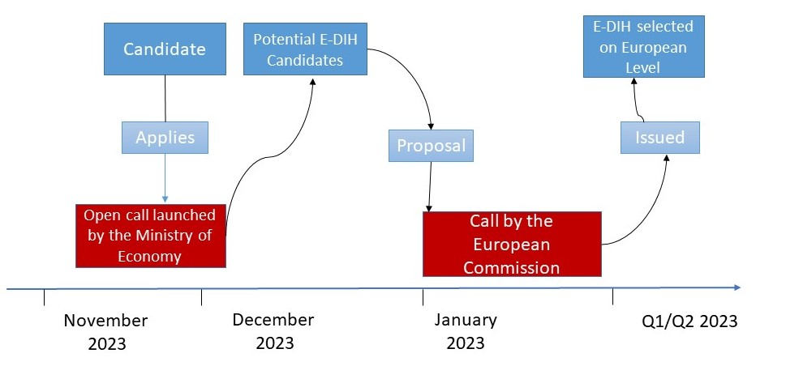
Figure 2: Timeline of the national and European selection process of the EDIH

EU selection

It is expected that on the 1st Quarter 2023, the European Commission will launch a call to the potential DIH’s designated by the Ministry of Economy. Candidates are advised to consult the EC documents for more information regarding this process, and the following link: https://european-digital-innovation-hubs.ec.europa.eu/information-associated-countries
All proposals will be evaluated by independent experts. After their technical evaluation, a strategic evaluation will take place where the European Commission, together with the Member States, will rank all the proposals above threshold in a list based on score, geographical coverage and specialisation coverage.
Funding
Eligibel costs
- Procurement and/or depreciation costs for equipment and facilities, both hardware and software
- Qualified personnel of the EDIH for delivering digital transformation services to SMEs including subcontracting for specialists
- Travel grants for hub personnel and local stakeholders to work with other hubs

Funding period
Digital Europe Programme foresees funding in the form of a grant, for a duration of 3-4 years with the possibility of reapplying at the end of the grant duration. After the duration of the grant(s), the capacities built up with the support of the Digital Europe Programme are expected to remain available to SMEs. It is not necessary to achieve full commercial sustainability after the end of the project. Since Digital Europe Programme is a capacity-building programme, country contribution should also aim at supporting capacity building of the EDIH.

Evaluation criteria

National Dimension

Relevance
The applicants must prove:
- the relevance of their focus of expertise with respect to the needs of the local economy;
- the fit of their focus with the government National Development Strategy – 2030, and Digital Agenda of Kosova 2030

Competences
The applicant must prove:
- the competences to provide the following services in its focus area:
  - test before invest,
  - support to find investments,
  - act as facilitator for training opportunities,
  - support to build an innovation ecosystem and promote networking opportunities;
- the ability to raise awareness of SMEs and public sector organisations on the benefits of digital transformation on a large scale.

Management capacity and infrastructure
The applicant must prove sufficient qualified staff (or capacity to hire) and an appropriate management capacity to provide the hub’s services. Furthermore they should have (access to) a physical infrastructure (a building to receive customers, training facilities, showroom / demonstration facilities, testing and experimentation equipment and facilities) that supports the objectives of the hub.
The applicant should also prove it has the operational and legal means to apply the administrative, contractual and financial management rules laid down at Union level, as well as be financially sound enough to manage the Union’s funds.
Finally, the selection process being long and uncertain, the candidates must prove they are sufficiently solid to go through this journey.

European dimension
Applications to the national call should in addition to specific national criteria be able to satisfy potential European Commission criteria and KPIs.
The evaluation elements of the European Commission are classified under three criteria: Relevance, Implementation and Impact.
Relevance
- Alignment with the objectives and activities as described in the Work Programme and in the call for proposals
- Contribution to long-term policy objectives, relevant policies and strategies, and synergies with activities at European and national level
- Extent to which the proposal can overcome financial obstacles such as the lack of market finance
Implementation
- Maturity of the proposed action and efficient use of resources
- Soundness of the implementation plan
- Capacity of the applicants, and when applicable the consortium as a whole, to carry out the proposed work and mobilise the necessary resources
Impact
- Extent to which the proposal will achieve the expected impacts listed in the Work Programme
- Extent to which the proposal will strengthen competitiveness and bring important benefits for society
- Extent to which the proposal demonstrates environmental sensitivity, including for climate change issues (e.g. through sustainable use of resources and/or contribution to circular economy/ green communication to the public).

Key Performance Indicators

To evaluate the hub and its evolution, a list of KPIs must be defined in the initial proposition submitted to the European call. These KPIs will be monitored during the whole Programme. Further information on the Commission process can be found on https://digital-strategy.ec.europa.eu/en/activities/edihs

Application form
Deadline: 6th of December 2023 CoB (16:00 PM)

Submission of filled in and signed application form to:

Ministry of Economy
Str. Mother Teresa, Nr. 36
10000 Prishtina
Republic of Kosova

- Coordinates of candidate / candidate consortium

Name, address, email, contact person and phone number of candidate or members of candidate consortium

- The candidate / candidate consortium: general information

B.1. | What the hub can do and which needs for the industry can be addressed; its focus and geographical area

B.2. | Governance structure of the candidate / candidate consortium

- The candidate / candidate consortium : specific information

C.1. | Competences related to the functions of the European Digital Innovation Hub

C.2. | Management capacity, staff and infrastructure necessary to carry out the functions defined above in C.1. ;
- Services provided

D.1. | Test before invest

D.2. | Skills and training

D.3. | Support to find investments

D.4. | Innovation ecosystem and networking opportunities
- European dimension

Explain how your proposal relates to other parts of the Digital Europe Programme. Explain how your proposed EDIH will contribute to achieve a well-functioning network of European Digital Innovation Hubs.
Describe your contacts and collaborations with other hubs where relevant to the call, competence/excellence centres, or other initiatives.
Describe the strategy that will be put in place to develop the international dimension of the proposed hub.

- Budget

F.1. | Description of the public or private source of the matching funds

- Signature

Candidate /member of candidate consortium: ……………………………………………………..
By signing the document, I certify that (please tick the boxes):
I have read and agree on the program guidelines ;
All the information provided in this document are correct ;
Name (legal representative): ………………………………………..………………………….
Position: …………………………………………………………………………………………………..

Signature & date: ……………………………….…………………………………………………….

Digital Europe Programme has the following definition: ‘European Digital Innovation Hub' means legal entity selected in accordance with Article 16 in order to fulfil the tasks under the Programme, in particular providing directly, or ensuring access to, technological expertise and experimentation facilities, such as equipment and software tools to enable the digital transformation of the industry, as well as facilitating access to finance. European Digital Innovation Hub shall be open to business of all forms and sizes, in particular to SMEs, midcaps, scale-ups and public administrations across the Union;
The beneficiaries should declare that for the activities covered by the grant they apply a not-for-profit objective, i.e. all money earned by them or donated to them is used in pursuing the EDIH’s objectives and keeping it running.

