First Meeting of the Inter-Institutional Coordination Commission for the Development of Cooperation on One Stop Shop for Renewable Energy Sources
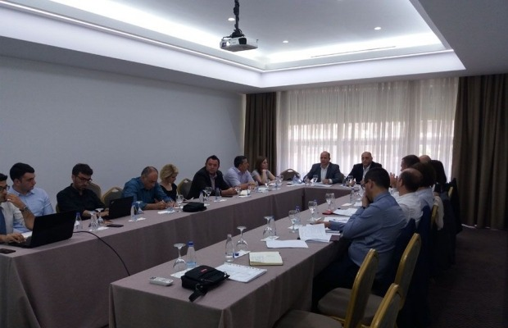
Prishtina, 10.06.2019 - The Inter-Institutional Coordination Commission on One Stop Shop for Renewable Energy Sources held its first meeting.
The meeting participants were delegated by the following institutions: MED, OPM, MESP, MTI, MAFRD-KFA, MoF, MLGA, ERO, KOSTT, KEDS, KAS, REPOWER experts, USAID etc.
During the meeting, there was a presentation of the whole chronology of the establishment of the One Stop Shop for RES and the establishment of the Inter-Institutional Coordination Commission for the development of cooperation on OSS for RES and the importance of this commission in coordination, cooperation and facilitation in the process of issuing permits to investors in the area of RES, as well as in relation to the obligations deriving from the SAA and ERA process.
The content of the Regulation 05/2018 was widely covered, starting from the purpose, scope, inter-institutional cooperation, foreseen tasks, drafting of the manual, etc.
An important document deriving from the Regulation 05/2018 is also the Manual of Procedures, the draft of which was presented during this meeting, outlining the ways of functioning of the Institutional Coordination Commission for the development and cooperation of OSS for RES, as a body of informative and coordination character serving the development of the RES sector.

